EMPLOYEE MANAGEMENT SYSTEM
Project 3 • Cloudexify Java Internship
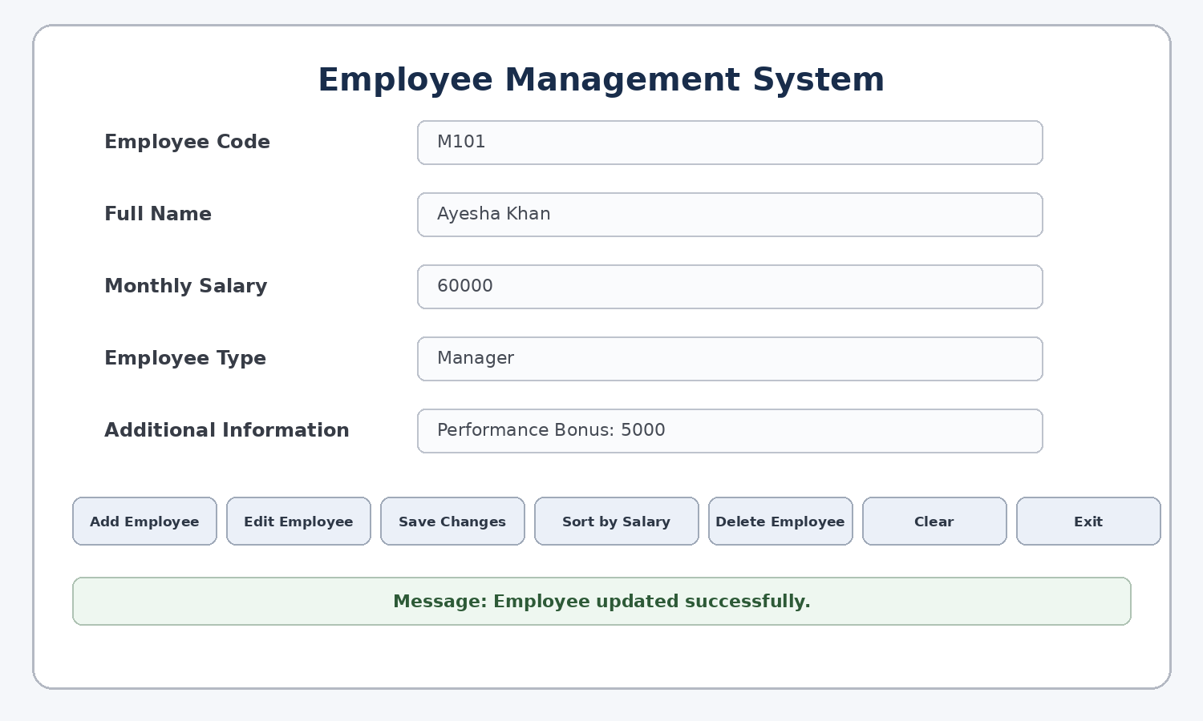
Figure 1 – Employee Management System GUI

Internship | Cloudexify Java Internship
Project | Project 3 – Employee Management System
Student / Roll No. | CX-INT-2026-JAVA-0076
Technology | Java with JavaFX
Package | com.mycompany.employeemanagementsystem
Document | Final Project Report

1. Project Overview
The Employee Management System is a GUI-based Java application developed as Project 3 of the internship. It uses JavaFX for the interface and object-oriented design for employee modeling. It supports Manager, Developer, and HR records together with add, edit, save, delete, sort, clear, exit, validation, and file persistence.

2. System Architecture
Layer | Classes | Responsibility
Domain / OOP | Employee | Common employee state and total-pay contract.
Domain / OOP | Manager, Developer, HR | Specialized employee behavior and pay rules.
Management | EmployeeApp | Collection, validation, CRUD, sorting, persistence.
Presentation | App | JavaFX controls, table, buttons, dialogs, events.
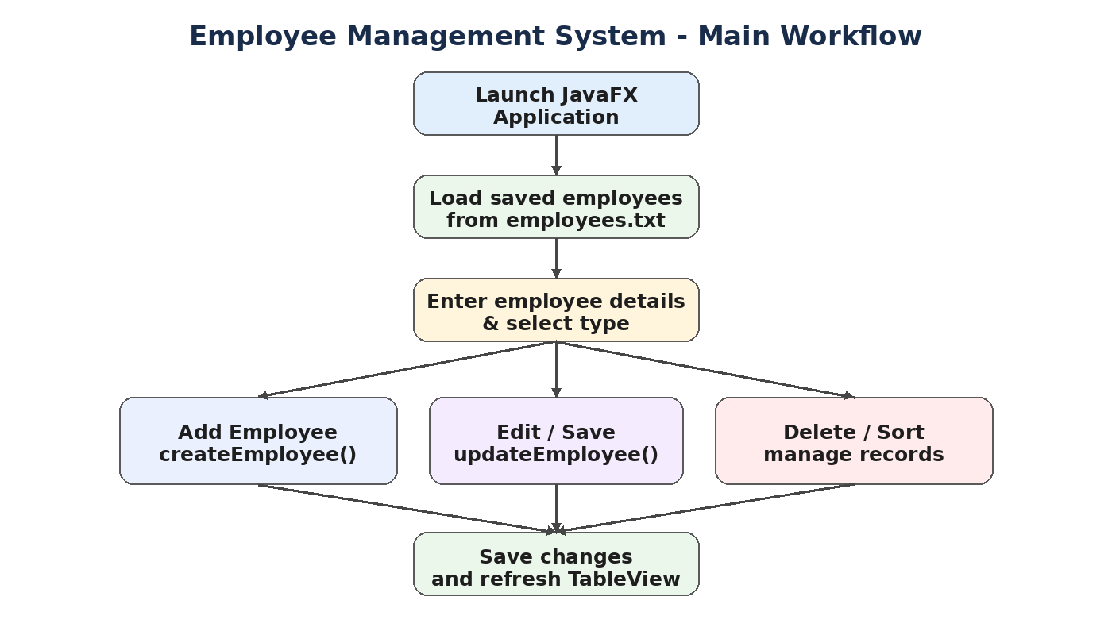
Figure 2 – Main application workflow

3. Object-Oriented Programming Concepts
Concept | Where | Implementation
Abstraction | Employee | Abstract parent and abstract getTotalPay().
Inheritance | Manager / Developer / HR | Each subtype extends Employee.
Polymorphism | Employee references | Different getTotalPay() implementations.
Encapsulation | Employee fields | Private fields with getters; employee code is final.
Exception handling | Constructors + App | Validation and input/file errors are handled.
Collections | EmployeeApp | ArrayList<Employee> stores records.

4. JavaFX GUI
The GUI contains fields for employee code, full name, monthly salary, employee type, and dynamic additional information. The main action sequence is Add Employee → Edit Employee → Save Changes → Sort by Salary → Delete Employee → Clear → Exit.

5. Functional Workflows
Add Employee
Validates input, creates the correct subtype, checks duplicate codes, saves, refreshes the table, shows a message, and clears the form.
Edit and Update
Loads a selected employee into the form. Code is disabled, Save Changes is enabled, and Add Employee is disabled. Saving creates the replacement object, updates the record, persists it, refreshes the table, then restores the normal button state.
Delete
Requires a selected row and displays a confirmation dialog. OK removes the record, saves the file, and refreshes the table.
Sort
Sorts by total pay in ascending order and refreshes the TableView.
Clear / Exit
Clear resets the form. Exit asks for confirmation before close.
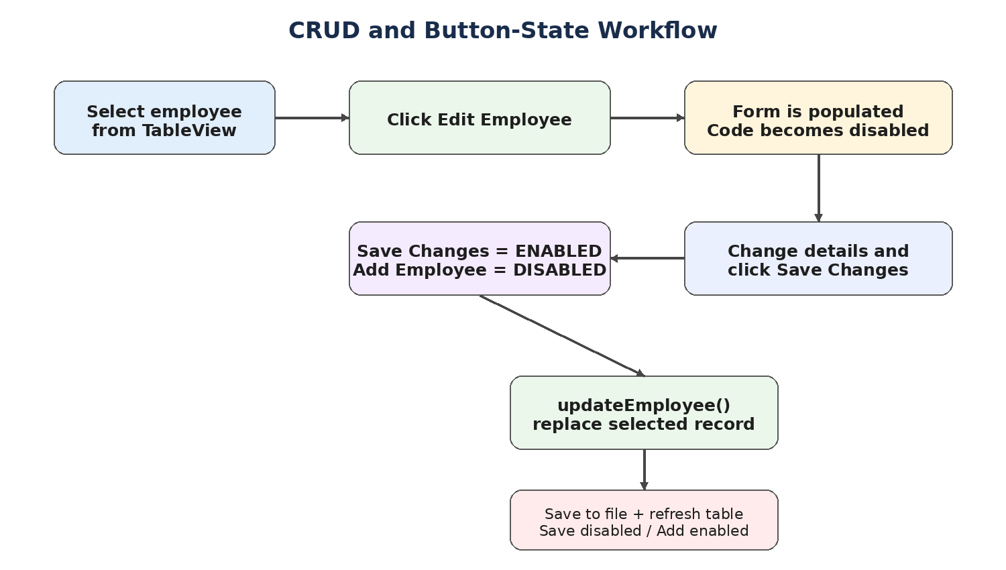
Figure 3 – CRUD and button-state workflow

6. File Handling
The application stores records in employees.txt. saveEmployees() writes employee data, while loadEmployees() reconstructs the appropriate employee subtype when the application starts. This keeps records available after restart.

7. Validation and Exception Handling
Case | Behavior
Empty required fields | Displays a completion message.
Non-numeric input | NumberFormatException is caught and reported.
Negative salary | Employee constructor rejects it.
Negative Manager bonus | Manager constructor rejects it.
Negative Developer experience | Developer constructor rejects it.
Duplicate employee code | register() rejects the new record.
No selected employee | Edit/Delete displays a selection message.

8. Testing
Test | Expected Result | Status
Add Manager | Correct total pay and table entry | PASS
Add Developer < 5 years | 10% increase | PASS
Add Developer ≥ 5 years | 20% increase | PASS
Add HR | 5% allowance | PASS
Duplicate code | Rejected | PASS
Edit + Save | Record replaced and persisted | PASS
Delete | Confirmation and removal | PASS
Sort | Ascending total pay | PASS
Clear | Form reset only | PASS
Exit | Confirmation | PASS
Restart | Saved records reload | PASS

9. Requirement Mapping
Requirement | Implemented Solution
Inheritance | Employee parent with Manager, Developer, HR subclasses.
Polymorphism | Different getTotalPay() implementations.
Exception handling | Input and constructor validation.
ArrayList | EmployeeApp stores employee objects.
GUI | JavaFX App class.
CRUD | Register, update, delete, retrieval.
Sorting | Comparator by total pay.
Persistence | BufferedReader/BufferedWriter and employees.txt.
State control | Save disabled initially; enabled in edit mode; disabled after save.

10. Conclusion
The completed Employee Management System provides a practical JavaFX interface combined with OOP, validation, CRUD operations, sorting, and persistent storage. The project demonstrates a complete workflow from entering an employee to modifying, deleting, sorting, saving, and reloading records. The current version is treated as the stable final baseline after functional testing.

11. Key Methods
Method | Purpose
register(Employee) | Adds validated employees and prevents duplicate codes.
saveEmployees() | Writes records to employees.txt.
loadEmployees() | Loads records at startup.
updateEmployee(...) | Replaces a record by employee code.
arrangeByPay() | Sorts by total pay.
removeEmployee(...) | Removes a record.
createEmployee() | Builds employee objects from GUI inputs.
editSelectedEmployee() | Loads selected record and changes button state.
saveEditedEmployee() | Updates, persists, refreshes, and restores state.
deleteSelectedEmployee() | Confirms and deletes a record.
updateExtraField() | Changes additional input according to type.
confirmExit(...) | Confirms application exit.

